Functional Model
Project Title: Shared Living Expense System
Course: COMP-699-A Professional Seminar
Professor: Prof. David Pitts
by
Bhargavi Dhulam

1. Use Case Diagram
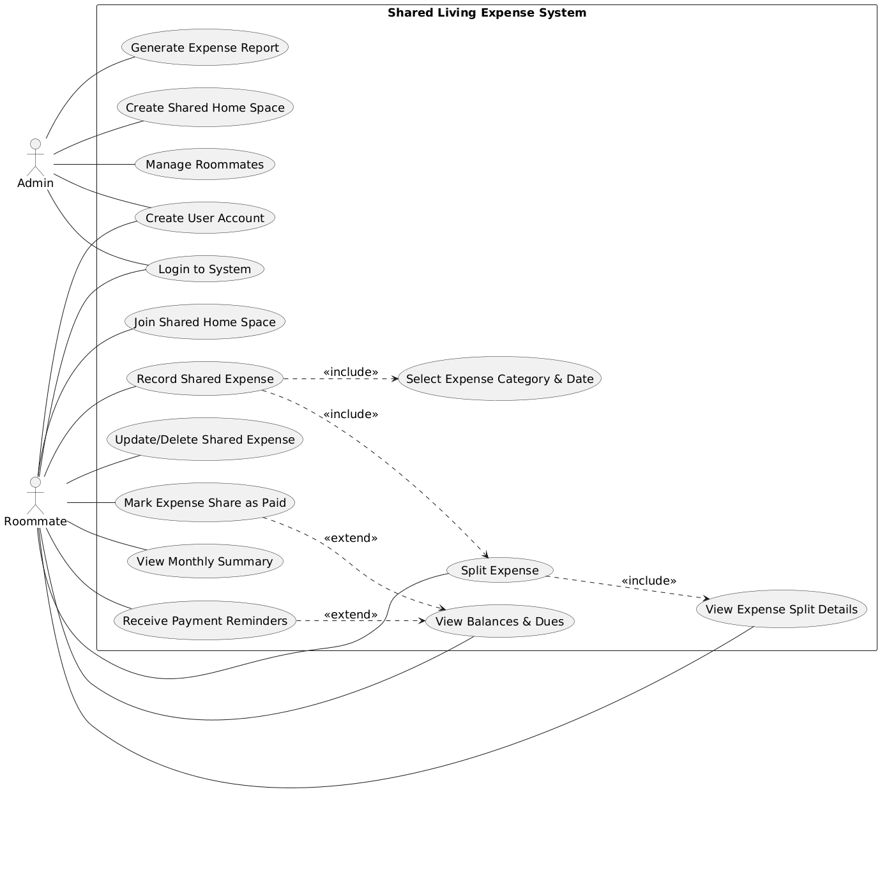Figure.1 Use Case Diagram

2. Use Case Description

1. Create User Account
Use Case No. | 1
Use Case Name | Create User Account
Primary Actor | Admin, Roommate
Trigger | User clicks the “Create Account” option
Pre-Conditions | User is not logged in. Registration page is accessible.
Post-Conditions | New user account is created and stored in the system.
Normal Flow | 1. User opens registration screen.  2. User enters name, email, and password.  3. User submits the form.  4. System validates all fields.  5. System creates a new account.  6. System shows confirmation message.
Exception Flow | 1. Required fields missing → system prompts user to complete them.  2. Email already exists → system shows duplicate account message.
Functional Req. | 1, 2

2. Login to System
Use Case No. | 2
Use Case Name | Login to System
Primary Actor | Admin, Roommate
Trigger | User selects the login option
Pre-Conditions | User account exists and is active.
Post-Conditions | User is logged in and redirected to dashboard.
Normal Flow | 1. User enters username and password.  2. User submits login request.  3. System validates credentials.  4. System grants access.  5. System loads user dashboard.
Exception Flow | 1. Invalid credentials → system displays error message.  2. Account locked → system informs user.
Functional Req. | 3, 4

3. Create Shared Home Space
Use Case No. | 3
Use Case Name | Create Shared Home Space
Primary Actor | Admin
Trigger | Admin selects “Create Home Space”
Pre-Conditions | Admin is logged in to the system.
Post-Conditions | New shared home space is created successfully.
Normal Flow | 1. Admin opens create home page.  2. Admin enters home name and details.  3. Admin submits request.  4. System validates inputs.  5. System creates the home space.
Exception Flow | 1. Invalid input → system shows error.  2. Duplicate home name → system asks for a different name.
Functional Req. | 7

4. Join Shared Home Space
Use Case No. | 4
Use Case Name | Join Shared Home Space
Primary Actor | Roommate
Trigger | Roommate enters invitation code/link
Pre-Conditions | Roommate is logged in. Invitation is valid.
Post-Conditions | Roommate becomes a member of the home space.
Normal Flow | 1. Roommate opens join home page.  2. Roommate enters invitation code.  3. System verifies the code.  4. System adds roommate to home space.  5. System shows success message.
Exception Flow | 1. Invalid code → system shows error.  2. Expired invitation → system rejects request.
Functional Req. | 9

5. Manage Roommates
Use Case No. | 5
Use Case Name | Manage Roommates
Primary Actor | Admin
Trigger | Admin selects manage roommates option
Pre-Conditions | Admin is logged in and owns the home space.
Post-Conditions | Roommate list is updated successfully.
Normal Flow | 1. Admin opens roommate list.  2. Admin selects add or remove option.  3. Admin confirms action.  4. System updates roommate list.  5. System shows confirmation.
Exception Flow | 1. Roommate not found → system shows error.  2. Cannot remove last admin → system blocks action.
Functional Req. | 8, 10

6. Record Shared Expense
Use Case No. | 6
Use Case Name | Record Shared Expense
Primary Actor | Roommate
Trigger | Roommate selects “Add Expense”
Pre-Conditions | Roommate belongs to a shared home space.
Post-Conditions | Shared expense is saved in the system.
Normal Flow | 1. Roommate opens add expense form.  2. Roommate enters amount and description.  3. Roommate selects category and date.  4. Roommate submits expense.  5. System stores expense.
Exception Flow | 1. Invalid amount → system rejects input.  2. Missing details → system prompts user.
Functional Req. | 12, 13

7. Update/Delete Shared Expense
Use Case No. | 7
Use Case Name | Update/Delete Shared Expense
Primary Actor | Roommate
Trigger | Roommate selects edit or delete option
Pre-Conditions | Expense exists and user has access.
Post-Conditions | Expense is updated or removed.
Normal Flow | 1. Roommate selects an expense.  2. Roommate edits or deletes expense.  3. System saves changes.  4. System updates balances.
Exception Flow | 1. Expense not found → system shows error.  2. Permission denied → system blocks action.
Functional Req. | 14, 15

8. Select Expense Category & Date
Use Case No. | 8
Use Case Name | Select Expense Category & Date
Primary Actor | Roommate
Trigger | Roommate fills expense form
Pre-Conditions | Expense entry is in progress.
Post-Conditions | Category and date are saved with expense.
Normal Flow | 1. Roommate selects category from list.  2. Roommate selects expense date.  3. System validates selection.
Exception Flow | 1. No category selected → system prompts user.
Functional Req. | 13

9. Split Expense
Use Case No. | 9
Use Case Name | Split Expense
Primary Actor | Roommate
Trigger | Roommate chooses split method
Pre-Conditions | Expense exists and roommates are available.
Post-Conditions | Expense is divided among roommates.
Normal Flow | 1. Roommate selects equal or custom split.  2. Roommate confirms split amounts.  3. System calculates shares.  4. System saves split details.
Exception Flow | 1. Total split mismatch → system rejects input.  2. Invalid amount → system prompts correction.
Functional Req. | 16, 17

10. View Expense Split Details
Use Case No. | 10
Use Case Name | View Expense Split Details
Primary Actor | Roommate
Trigger | Roommate selects view split option
Pre-Conditions | Expense with split exists.
Post-Conditions | Split details are displayed.
Normal Flow | 1. Roommate selects an expense.  2. System displays each member’s share.
Exception Flow | 1. Expense not found → system shows error.
Functional Req. | 18

11. View Balances & Dues
Use Case No. | 11
Use Case Name | View Balances & Dues
Primary Actor | Roommate
Trigger | Roommate opens balances page
Pre-Conditions | User is logged in and part of home space.
Post-Conditions | Current balances and dues are displayed.
Normal Flow | 1. System retrieves balance data.  2. System displays amounts owed and owed by others.
Exception Flow | 1. No balance data → system shows empty state.
Functional Req. | 19, 20, 21

12. Mark Expense Share as Paid
Use Case No. | 12
Use Case Name | Mark Expense Share as Paid
Primary Actor | Roommate
Trigger | Roommate selects mark as paid
Pre-Conditions | Pending payment exists.
Post-Conditions | Payment status is updated.
Normal Flow | 1. Roommate selects expense share.  2. Roommate marks as paid.  3. System updates payment status.  4. System updates balances.
Exception Flow | 1. Already marked paid → system shows notice.
Functional Req. | 22

13. View Monthly Summary
Use Case No. | 13
Use Case Name | View Monthly Summary
Primary Actor | Roommate
Trigger | Roommate selects a month
Pre-Conditions | Monthly expense data exists.
Post-Conditions | Monthly summary is displayed.
Normal Flow | 1. Roommate selects month.  2. System loads summary.  3. System displays totals and shares.
Exception Flow | 1. No data for month → system shows message.
Functional Req. | 24, 25

14. Receive Payment Reminders
Use Case No. | 14
Use Case Name | Receive Payment Reminders
Primary Actor | Roommate
Trigger | Payment becomes overdue
Pre-Conditions | Pending payment exists.
Post-Conditions | Reminder is sent to user.
Normal Flow | 1. System checks overdue payments.  2. System sends reminder notification.
Exception Flow | 1. Notification fails → system logs error.
Functional Req. | 26, 27

15. Generate Expense Report
Use Case No. | 15
Use Case Name | Generate Expense Report
Primary Actor | Admin
Trigger | Admin selects generate report
Pre-Conditions | Admin is logged in.
Post-Conditions | Expense report is generated.
Normal Flow | 1. Admin selects time period.  2. System collects expense data.  3. System generates report.  4. System displays report.
Exception Flow | 1. No data → system generates empty report.
Functional Req. | 28, 29, 30

3. Activity Diagram
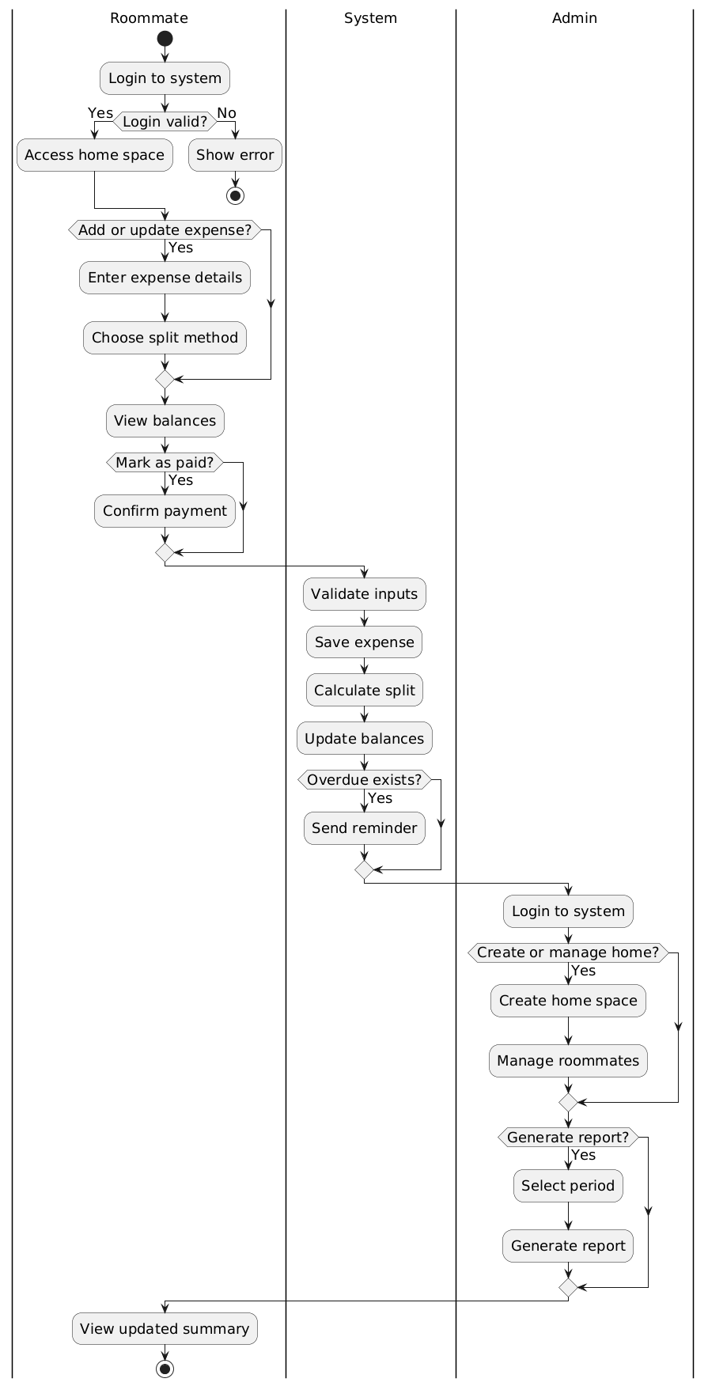
Figure.2 Activity Diagram

